**Cisco IOS Command Summary CCNA 1 (Introduction to Networks)– Chapters 2-11**

Do you want to go to initial dialog (yes/no): no

Do you want to terminate autoinstall (yes/no): yes

Ctrl+Shift+6 (terminate domain server search [255.255.255.255])

*! this character (!) starts one line comment in running-config*

**High-level Schematic Diagram of Some IOS Commands**

**Cisco IOS CLI hierarchy**

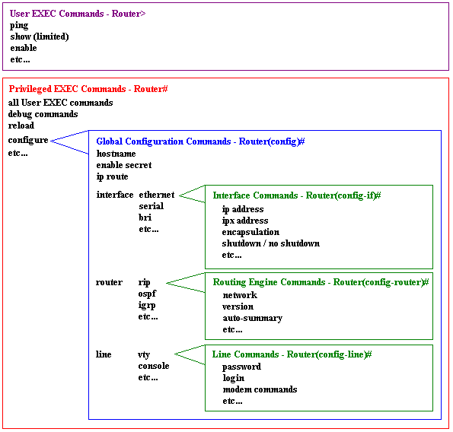

Switch>enable !User Exec mode

Switch#configure terminal !Privileged Exec mode

Switch(config)# !Global configuration mode

Switch(config)#hostname Sw1

Sw1(config)#enable secret class !2nd option is password

Sw1(config)#service password-encryption ! Encrypt all clear text password in running-config

Sw1(config)#security password min-length 8 !8=characters

Sw1(config)#login block-for 120 attempts 3 within 60 ! Seconds

Sw1(config)#banner motd #Warning!#

Sw1# clock set 15:00:00 31 Jan 2035

Sw1(config)#line console 0 !Global mode Line sub command mode

Sw1(config-line)#password cisco

Sw1(config-line)#login !Ask the password on next console login

Sw1(config-line)#exit

Sw1(config)#line vty 0 4

Sw1(config-line)#password cisco

Sw1(config-line)#login !Ask the password on next telnet/ssh login

Sw1(config)#ip default-gateway 10.1.1.5 ! default gateway IPv4 address for the Sw1

!Global mode interface sub command

Sw1(config)#interface vlan 1 !Management IP of the device

Sw1(config-if)#ip address 10.1.1.5 255.0.0.0

Sw1(config-if)#no shutdown

!Global mode interface sub command

R1(config)#interface s0/0/0 !go to serial port’s configuration mode

R1(config-if)#ip address 10.1.1.5 255.0.0.0 !give the IPv4 host address and subnet mask

R1(config-if)#clock rate 64000 !set the clock rate to the serial port’s DCE side

R1(config-if)#no shutdown ! set the port on (shutdown = set the port off)

!Global mode interface sub command

R1(config)#interface fa0/0 !go to fast ethernet port’s configuration mode

R1(config-if)#ip address 11.1.1.5 255.0.0.0 !give the IPv4 host address and subnet mask

R1(config-if)#no shutdown ! set the port on (shutdown = set the port off)

R1(config-if)#description Sw1-port-to-LAN2 ! Description text (=comment) for a port

R1#copy running-config startup-config !save running-config from RAM to NVRAM

R1#reload !Restart the device (Save? Yes/No)

Sw1# show running-config !Show current configuration (in the RAM)

Sw1# show startup-config !Show current configuration (in the NVRAM)

Sw1#show ip interface brief !Show list of all interface and the status of them

Sw1#show ip interface fa0/0 !Show specific interface’s data

Sw1(config-if)#do show running-config !Do when you give other mode’s command

R1# show ip route ! display the router’s routing table information

Sw1(config-if)#no ip address !Delete interface’s ip address

Sw1(config)#no hostname !Delete host name

R1(config)#line vty 0 4

R1(config-line)#login local !ssh uses local username and password

R1(config-line)#transport input ssh !only ssh connections are allowed

R1(config-line)#exec-timeout 10 ! Minutes

R1(config-line)#exit

R1(config)#username kalle password kallepass !local username & password

R1(config)#ip domain-name span.com

R1(config)#crypto key generate rsa 1024 !1024 = length of the key

R1#copy running-config tftp

R1#copy tftp flash

PC>tracert Destination IP !Windows command

R1#traceroute Destination IP !Unix command

**IPv6 Commands**

R1(config)# ipv6 unicast-routing ! **Enable the router to forward IPv6 packets**

R1(config-if)# ipv6 address 2001:DB8:1:1::1/64 ! **Configure unique global IPv6 address**

R1(config-if)# ipv6 address FE80::1 link-local ! **Configure static IPv6 link-local address**

R1#show ipv6 interface brief

R1#show ipv6 route